5.4 Green’s Theorem Worksheet

- Consider the work done by the vector field on a particle moving counterclockwise around the unit circle.
- Use Green’s Theorem to evaluate the resulting line integral.

- How would your answer change if the particle was moving clockwise around the unit circle?

- Use Green’s Theorem to evaluate the line integral where and C is the triangle joining , , and in the counterclockwise direction.

- Evaluate , where C is the circle .

- Suppose an object is being spun by high wind currents modelled by the vector field in a counterclockwise fashion around a circle of radius 2. Determine the total work done by the wind currents on the object as the object moves around the circle once.

- Determine the work done by the vector field on a particle moving along C, where C is the boundary of the region outside the unit square but inside the circle with positive orientation.

- Use Green’s Theorem to evaluate the line integral along the given positively oriented curve.

where C is the boundary of the region enclosed by the parabolas and .
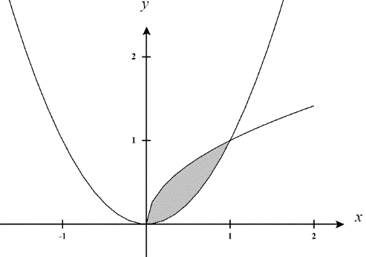

- Explain why green’s theorem cannot be used to evaluate the following line integral:

where C is the boundary of positively oriented unit circle.

- Compute , where C is the negatively oriented boundary of the region enclosed by , the x-axis, and .

- Use Green’s Theorem to evaluate the following line integral where C is the path from to along a line, followed by the path from to along the top half of a circle of radius 3 centered at the origin, followed by the path from to along a line, followed by the path from to along the top half of a circle of radius 1 centered at the origin.

- Evaluate , where C is the ellipse .

